CHAPTER 12
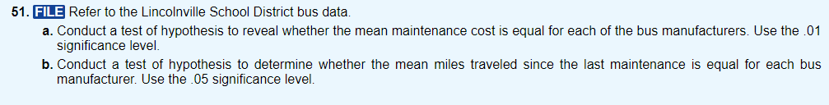
CHAPTER 15
